Bibb County Day Trip Article
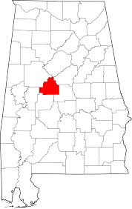
There are many different things that people may think of when they hear “Alabama,” but being known for extraordinary wildlife may not be one.

However, Alabama is home to one of the nation’s newest National Wildlife Refuges, established in 2002, that protects a portion of the Cahaba River and surrounding land. The Cahaba River supports 64 rare and imperiled plant and animal species, 13 of which are found nowhere else in the world. The river has more fish species than any other river its size in North America.

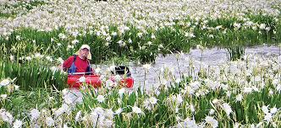
While visiting the Cahaba River and the National Wildlife Refuge at any time of the year is a wonderful experience, the summer months are peak time for the Cahaba lily. The plant blooms so beautifully and there are so many of them, that people come from across the region to see the lilies and visit the annual Cahaba Lily Festival the last Saturday in May.

A gem of a lunch spot, Brierfield Café, is fairly unassuming from the road but one bite of food and you’ll make sure to never drive past it again. With rocking chairs on the porch and locally sourced vegetables from the Alabama Farmer’s Market (including fried green tomatoes!), Brierfield Café will give you that Southern charm.

In addition to the Cahaba River, there are plenty of other outdoor adventures to seek out, including the Payne Lake Recreation Area and Brierfield Ironworks Historical State Park.

Payne Lake offers water activities, like kayaking, canoeing and fishing, in addition to camping, hiking and biking. At Brierfield, one can view living history with pioneer cabins, restored buildings and the crumbling brick walls of a 60-foot furnace built in 1862. One can also swim, hike and camp at the site.

After a full day of the outdoors at one of the many options Bibb County has to offer, a hearty dinner is in line. Lemley’s Tiger Hut offers the best burgers in town, home cooked fresh to order! The milkshakes are also a popular item on the menu.

As for lodging, there are a couple of options. Brierfield offers cabins and camping. There’s also the Windwood Inn in Brent.

Mentioned Attractions:
Payne Lake Recreation Area
581 CR 71
Moundville, AL 35474
205-926-9765

Brierfield Café (BBQ)
19717 Highway 139
Brierfield, AL 35035
205-665-0022

Brierfield Ironworks Historical State Park
240 Furnace Pkwy.
Brierfield, AL 35035
205-665-1856

Cahaba River National Wildlife Refuge
291 Jimmy Parks Blvd.
Anniston, AL 36205
205-848-7085

Lemley’s Tiger Hut
Main Street, West Blocton, Alabama
(205) 938-7737

Windwood Inn
2923 Main St.
Brent, AL
(205) 926-4833

For a complete listing of the many attractions in West Alabama and Bibb County, visit http://www.tourwestalabama.com/county-overall/bibb-county/

