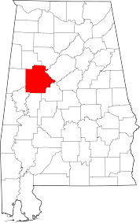
Greene County
With just part of an afternoon to go exploring and site seeing, you must see the many historic homes and plantations in and near Eutaw, Alabama. While many of the homes are drive-by only, as they are currently private residences, the exterior of the homes, landscaping and neighborhoods offer a quaint look at how life used to be.

Begin with the Asa White house, also known as the White-McGiffert house, at the intersection of Mesopotamia and Eutaw Streets. Colonel Asa White, one of the first settlers in the county, built the house in 1838. The town of Eutaw as a whole was established on property owned by White. The house was photographed and recorded by the Historic American Buildings Survey in 1936. It was added to the National Register of Historic Places April 02, 1982. (Drive-by only).

Next is the Beckham Dye Palmer House at 315 Boligee Street. This house was built in stages as the Palmer family grew, at one point having three kitchens for the family. It is also reportedly the first house in the county to have electricity. (Drive-by only.)

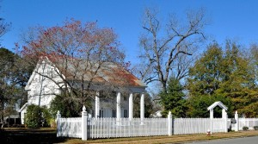
After a short walk, you will arrive at the Dr. Willis Meriwether House at 243 Wilson Avenue. A two-story wood framed building on a brick foundation, the house was moved by Dr. Willis Meriwether from his plantation to the current site in 1856. The historic vernacular Greek Revival style house was recorded by the Historic American Buildings Survey in 1934. Due to its architectural significance, it was added to the National Register of Historic Places as a part of the Antebellum Homes in Eutaw TR multiple property submission on April 02, 1982.

Right next-door is the Capt. Edwin Reese House, also known as Basil Hall at 244 Wilson Avenue. Four huge columns on the front portico give the Greek Revival style house a decidedly southern feel. It was listed on the Alabama Register of Landmarks and Heritage on October 17, 1980 and added to the National Register of Historic Places as a part of the Antebellum Homes in Eutaw TR multiple property submission on April 02, 1982, due to its architectural significance. (Drive-by only.)

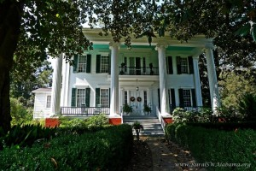
Eutaw square merchant William Perkins built the next house, nicknamed White Columns at 89 Spencer Street. He purchased the six-acre lot from Asa White in 1841. Restored in the 1970’s as one of four surviving antebellum-pillared mansions in Eutaw, this house rests atop a high brick foundation, which adds to the monumental feeling.

As you walk to the next house, the path takes you along the Greene County Courthouse Square. Feel free to take a pit stop at Trumans Original BBQ on Tuscaloosa Street.

Lastly, the Coleman-Banks House, also known as the James Oliver Banks House, is the first of four antebellum homes at Eutaw, AL to have original colossal-order porticos. It is located at the intersection of Springfield Avenue and Pickens Street. The house, featuring a double porch (on the first and second stories) was photographed and recorded in the Historic American Buildings Survey in 1934. It was added to the National Register of Historic Places on December 18, 1970. (Drive-by only.)

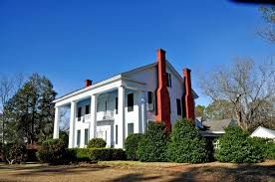
Finish off your tour of beautiful historic houses by driving to Everhope Plantation, beside Highway 14, seven miles northwest of Eutaw. The house, originally part of a 667-acre cotton plantation, was built in 1852 for Captain Nathan Carpenter. The house remained in the Carpenter family for 122 years, until 1974. After a series of different owners for the next thirty years, Barden Smedberg purchased the house in 2012 and opened it as Everhope Plantation Bed and Breakfast. The home is available for tours, as well as weddings and events. The gorgeous home, with a beautiful walk-up pathway lined with hedges and landscaping is a must-see.

For a complete listing of the many attractions in West Alabama and Greene County, visit http://www.tourwestalabama.com/county-overall/greene-county/

