Hale County Day Trip Article
If you want to step back in time, Hale County is the place to visit.

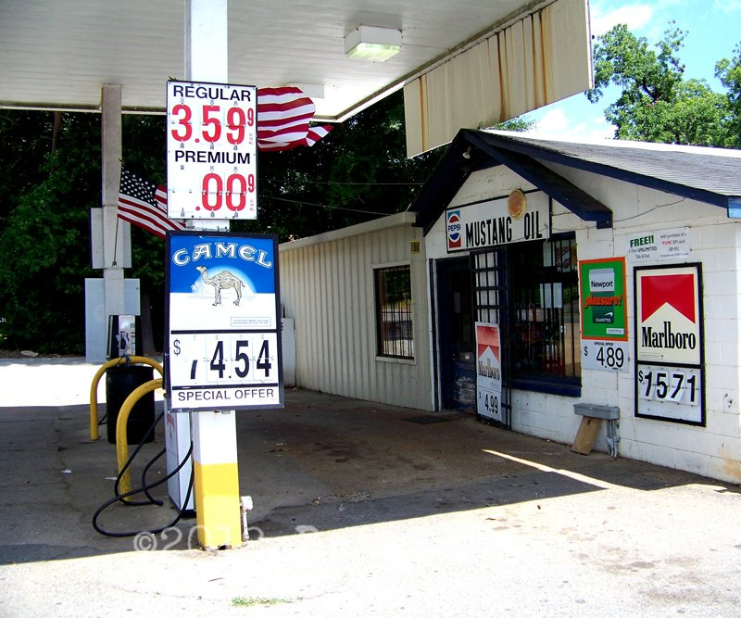
On your way into Hale County, stop by Moundville Archaeological Park. It was once the site of a powerful prehistoric community that was America’s largest city, north of Mexico. The park preserves 326 acres where Mississippian Indians constructed 28 massive flat-topped earthern pyramids, arranged around a vast central plaza. The mounds served as elevated platforms for civic and ceremonial structures. They are quite the site to see today!

Next, visit Mustang Oil, a quirky restaurant inside of an old gas station, for lunch. See the vintage pumps, signs and memorabilia from years ago. Everyone has a different favorite item on the menu, which is a good sign that all of the food is delicious!
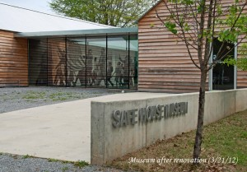
After visiting the 50s at the gas station-turned-restaurant, visit another attraction from that period: The Safe House Museum. On the night of March 21, 1968, Martin Luther King Jr. sought refuge from the Ku Klux Klan inside a small shot-gun style home in the depot neighborhood of Greensboro, Alabama. Today that house is known as The Safe House Black History Museum. It is a site of great significance to American Black History as well as the Civil Rights Movement of the 1950’s and 1960’s.

There’s a great shopping scene downtown. It is worth noting The Partridge Berry in Greensboro, which has unique gifts, home décor, clothing and accessories.

The Greensboro Opera House was built in 1903 when the previous opera house burned down. Typical for opera house design at the time, the Greensboro Opera House was a grand building in a small town like Greensboro. Today, the Opera House regularly hosts interesting events, so check their website for current information. It also has a beautiful window display, showcasing what one would wear to the opera at different points in time. Overall, the building and displays are breathtaking.

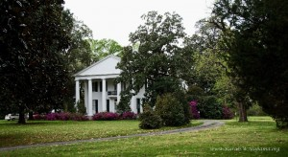
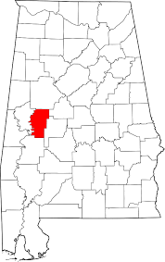
Head out to Magnolia Grove in Greensboro for a step farther back into time. Nationally significant as the boyhood home of Spanish-American War hero and U.S. Congressman Richmond Pearson Hobson, Magnolia Grove is a Southern archetype of what many tourists expect to see in the Deep South. The house was built around 1840 and is surrounded by beautiful flowering bushes, supported by tall white columns, filled with original family furniture and was built with handmade brick. Magnolia Grove is a historic house museum located on 15 acres at the west end of Greensboro's historic district.

As for a place to stay, an amazing bed and breakfast is situated on 320 acres just outside of the city. Pecan trees, azaleas, gardenias and magnolia trees surround Blue Shadows Bed and Breakfast. The land includes a formal garden, nature trail, large barn and a lake for fishing. With this many features, you may just want to stay another day to take in the beautiful landscaping and scenery out in the country. Also, Tuscaloosa is located just 45 minutes away and has plenty of big-name hotels.

Moundville Archaeological Park
634 Mound State Parkway
Moundville, AL 35474
(205) 371-8732
Mustang Oil
2205 Main Street
Greensboro, AL 36744
(334) 624-9301

Safe House Museum
2401 Davis Street
Greensboro, AL
334-624-2030

The Partridge Berry
1305 Main Street
Greensboro, AL 36744
(334) 624-9009

The Greensboro Opera House
1215 Main Street
Greensboro, AL
(3345) 624-8374

Magnolia Grove
1002 Hobson Street
Greensboro, AL 36744
334-624-8618

Blue Shadows Bed and Breakfast
11265 AL Highway 14
Greensboro, AL 36744

For a complete listing of the many attractions in West Alabama and Hale County, visit http://www.tourwestalabama.com/county-overall/hale-county/

