Lamar > Fayette
Start the day off right with a heart breakfast at Happy Days Café, a wonderful brunch spot. The restaurant has a fun oldies theme, with photos of Elvis and Marilyn Monroe covering the walls.
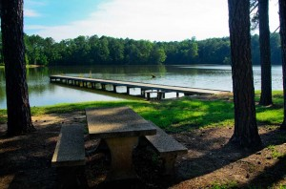
After breakfast, you should head out to Lamar County Lake. This 68-acre lake is a favorite with local fishermen and has stunning views of the surrounding forests. Bird watching is a popular hobby in the area, with a variety of birds frequenting the area, including Barn Swallows, Purple Martins, American Goldfinches and Pine Warblers. Bird boxes, seed feeders, and hummingbird feeders hanging from the porch of the fishing store attract Ruby-throated Hummingbirds and other feeder birds. Hiking access is available, but the beautiful landscape of open woods, as well as the birds that inhabit it, is easily viewable from the gravel entrance road along the property.
If you don’t bring along a picnic to the lake, Sam’s Smokehouse is a wonderful BBQ option for lunch. Named a finalist to AL.com’s Alabama’s Best BBQ Ribs, Sam’s Smokehouse offers hickory-flavored ribs that fall off the bone, among an entire menu of delicious BBQ options.
After spending the majority of the day outside in the Alabama sun, visiting a pool sounds like a great idea. Fayette Aquatic Center features multiple pools and waterslides for every age. Waterslides, drop slides, a diving board, spray pad and 5,380 square foot pool will certainly cool you off after an adventurous day.
If you’d rather spend some time inside after an adventurous day, there is great shopping in downtown Fayette!
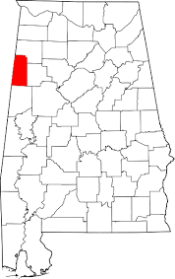
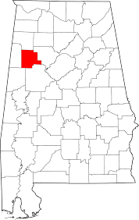
Lastly, Huatulco Mexican Restaurant is a wonderful stop for dinner on the way home. With great service and more than enough food to get your bang for your buck, this restaurant is the place to be.
If you need a place to stay the night, Rose House Inn is a great option.

Happy Days Café
525 Front Street
Sulligent, AL 35586
205-698-8832

Lamar County Lake
455 Fishing Lake Road
Sulligent, AL 35586
205-695-8283
http://alabamabirdingtrails.com/sites/lamar-county-fishing-lake/

Sam’s Smokehouse
460 Columbus Street E
Fayette, AL 35555
205-932-5827

Fayette Aquatic Center
218 23rd Street NE
Fayette, AL 35555
205-932-2196
Huatulco Mexican Restaurant
1520 Temple Avenue N, Fayette, AL 35555
(205) 904-9721

Rose House Inn
325 2nd Ave NW
Fayette, AL 35555
(205) 932-7673

For a complete listing of the many attractions in West Alabama and Lamar and Fayette Counties, visit http://www.tourwestalabama.com/county-overall/lamar-county/ and http://www.tourwestalabama.com/county-overall/fayette-county/

FAYETTE > LAMAR

When visiting Fayette, you must visit the museums in town. Choosing between the Fayette Art Museum and the Fayette Depot Museum may be tough. In that case, just go to both!

The Fayette Art Museum showcases over 4,000 pieces and six different folk art galleries, with 500 running feet of display space. The museum was founded when Lois Wilson, a Fayette native, donated her art collection, totaling 2,600 pieces. The museum values Southern art and strives to promote and preserve their pieces. Fayette, Alabama, was put on the tourist map when National Geographic flagged the museum as a regional attraction in 1999. The Fayette Art Museum often puts on events for all ages, so be sure to check that out when planning a trip.

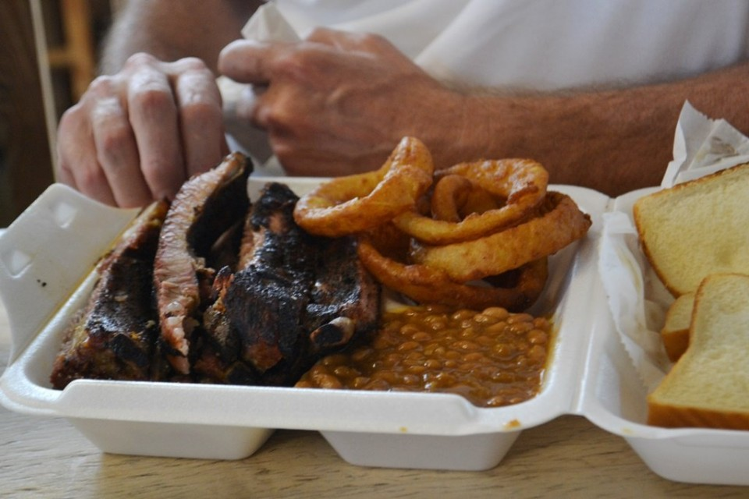
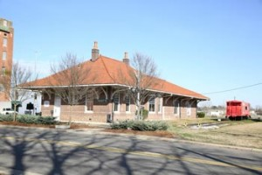
Another wonderful museum choice in Fayette is the Fayette Depot Museum. Located in the restored, historic train station that was constructed in 1887, the museum displays many local, historical artifacts from eras past, including a Civil War-era drum, an extensive collection of flags and a train track with model trains. The most recent addition to the museum is a model displaying an exact replica of downtown Fayette, which took two years and $20,000 to complete. It is only open on Sundays.
Stop by Sam’s Smokehouse for some wonderful BBQ before heading to Lamar. Named a finalist to AL.com’s Alabama’s Best BBQ Ribs, Sam’s Smokehouse offers hickory-flavored ribs that fall off the bone, among an entire menu of delicious BBQ options.

The Lamar Theatre in Vernon, Alabama offers Saturday night entertainment, with shows offering as many as 25 different entertainers! The show varies every Saturday in entertainers and genres, ranging from country, to gospel, to blues or comedy. Open every Saturday from 6:30-10:30 p.m., The Lamar Theatre is not something to miss, as you never know what you’ll get.

With a late night at the Lamar Theatre, Rose House Inn will be a welcome sight to stay over. One of the oldest homes in Fayette, the southern hospitality of the bed and breakfast is charming.

Fayette Art Museum
530 North Temple Avenue
Fayette, AL 35555
205-932-8727
http://fayetteartmuseum.vpweb.com/default.html

Fayette Depot Museum
202 South Temple Avenue
Fayette, AL 35555
205-932-4587

Back Street Opry at Lamar Theatre
1st Avenue NE
Vernon, AL 35592
205-695-7029
Rose House Inn
325 2nd Ave NW
Fayette, AL 35555
(205) 932-7673

For a complete listing of the many attractions in West Alabama and Lamar and Fayette Counties, visit http://www.tourwestalabama.com/county-overall/lamar-county/ and http://www.tourwestalabama.com/county-overall/fayette-county/

