Pickens County Day Trip Article
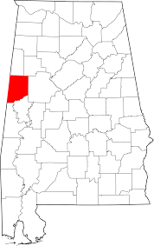
Begin your day by eating at Billy’s in Northport. It offers a wonderful brunch that can’t be beat. The reasonable prices plus the delicious food is a combination that can’t be missed.

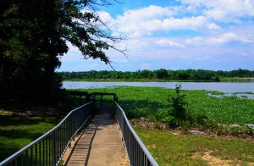
Next, head over to the Pickensville Recreation Area, just west of Pickensville, Al, on Aliceville Lake on the Tennessee-Tombigbee Waterway. The campground offers a day use area and general campground, plus activities and amenities for all ages. Visitors can enjoy hunting, fishing, water sports and watching the barges travel along the waterway. Fisherman can try their luck on the fishing dock or go offshore to look for bass, walleye, crappie, catfish and sunfish. Families can swim at Pickensville’s beach, play on the playgrounds, walk along the wooded bank and dock or learn about the history of the area at the amphitheater.

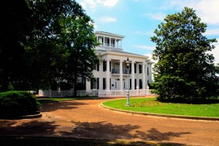
If you’re interested in learning more about the past, check out the adjacent Tom Bevill Visitor Center, which showcases an authentic reproduction of a mid-nineteenth century plantation house surrounded by beautiful landscaping.

If you decide to not have a picnic at the Pickensville campground or need to experience some air-conditioning for a minute, Gates Restaurant in town is the go-to for lunch. The classic southern favorites like pulled pork, fried green tomatoes, turnip greens, fried okra and sweet tea are all staples at the restaurant.

To continue the outdoor adventure theme, Shark Tooth Creek Outdoor Adventures is not only the place to go for more camping, fishing and canoeing, but also a short hayride will take you down to the creek to look at shark teeth and fossils. Be sure to call and set up an appointment before arriving.

Head back through Gordo for dinner at Billy’s BBQ and a stay at any of the three hotels in Northport: Best Western Catalina, Budget Inn or Econolodge.

For a complete listing of Pickens County attractions, visit http://www.tourwestalabama.com/county-overall/pickens-county/

