Tuscaloosa

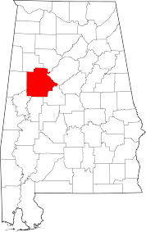
Shrouded in tradition, Tuscaloosa is full of Crimson Tide pride, but also offers plenty of other attractions to check out!
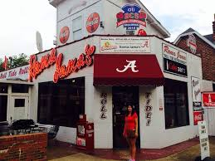
Start your day off right with a brunch at Rama Jama’s, the Alabama-obsessed restaurant with all-day breakfast. The iconic restaurant is across the street from Bryant-Denny Stadium and is a game-day staple.

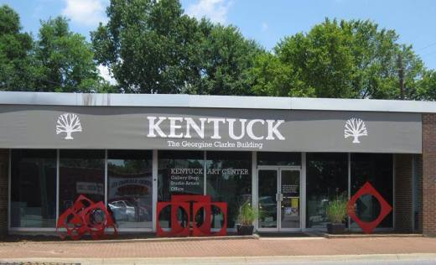
Next, visit The Paul W. Bryant Museum, right down the road. Founded in 1985, the museum was opened in 1988 to “house the history of Alabama football, with special emphasis on the legendary Coach William “Bear” Bryant.” The museum houses over 1,000 videos of Tide games and exhibits memorabilia, such as a Waterford crystal replica of Coach Bryant’s houndstooth hat and the Daniel A. Moore painting used to create the Bear Bryant U.S. mailing stamp. Open from 9 a.m. to 4 p.m. everyday, The Bryant Museum is a shrine to Alabama football.

Tuscaloosa has more to offer than just football though! The Kentuck Arts Center offers exhibitions, classes and shopping year-round. The galleries, working artists’ studios, clay co-op and shops are situated around the Courtyard of Wonders, which features shady retreats and sculptures.

Other art options in the area include the Tuscaloosa Museum of Art and Paul R. Jones Gallery. The museum is considered to be one of the greatest private collections of American art in the world. The Paul R. Jones Gallery at The University of Alabama is one of the largest collections of African American art in the world.
After you are worn out from browsing and shopping all day, grab dinner at DePalma’s Italian Café. The meatballs are to-die for! The restaurant is just a couple blocks from the newly built Embassy Suites by Hilton in Downtown Tuscaloosa for a place to stay that night!

For a complete listing of the many attractions in West Alabama and Tuscaloosa County, visit http://www.tourwestalabama.com/county-overall/tuscaloosa-county/

